Connecting the Lessons of World War One to the present:
Understanding the Enduring Issue of how the truth can be manipulated
Media Literacy:
-When ________________ become aware (literate) of how images and stories are created, spread, or even manipulated. (changed)
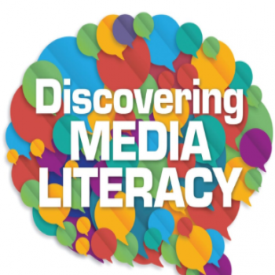
-Being Media Literate is important because if “We the People” don’t challenge where our facts come from, it is easy to be __________ to.
“Fake News”:
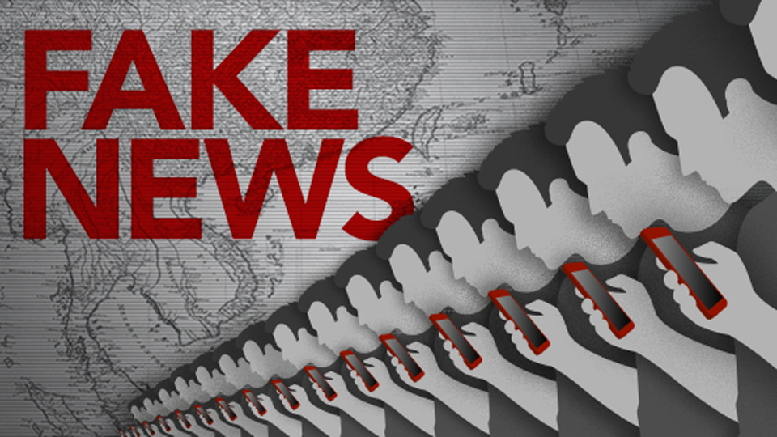
-The nickname for when a story is manipulated, changed, or just plain ____.
-It is also has become a term that people use when they want to challenge a real story that they don’t like or are __________________________ with.
Journalist/”The Press”:
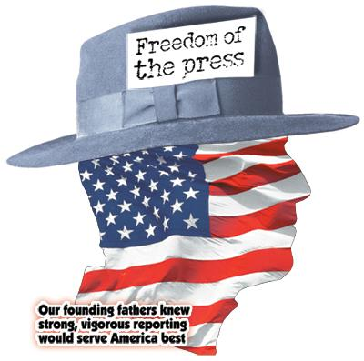
-a person/organization who researches, writes, and produces _____ stories
-Our Founding Fathers thought that journalists and a free press were a crucial factor in a democracy, challenging those in power to tell the ______.
Conspiracy Theory:
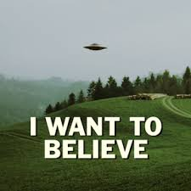
-A form of Fake News that questions real stories that are established _____.
-(A “conspiracy” is when those in power lie or __________ citizens.)
-These theories can often do great damage to a society.
Why can social media be dangerous to a democracy?
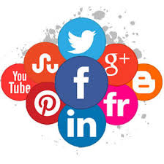
-The scary part of social media is that a citizen, politician, country, or group can spread a ________ story about society or someone they disagree with. -These stories can often _______ Americans and lead to mistrust/violence.

