Student Briefing Packet
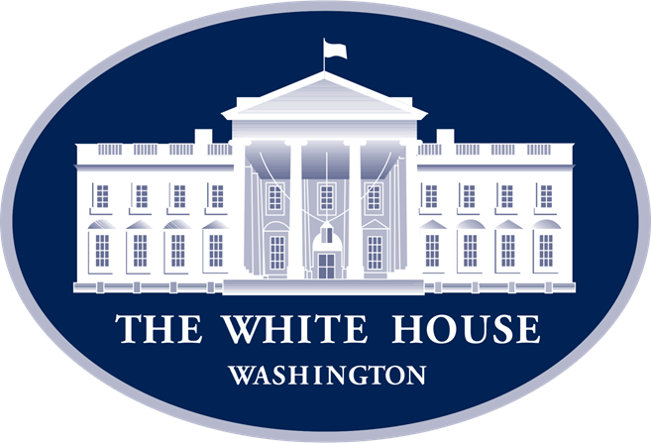
Inside the White House Situation Room:
A Presidential Advisory Meeting about what to do about the dangers of a nuclear North Korea

Student Name: ____________________________________

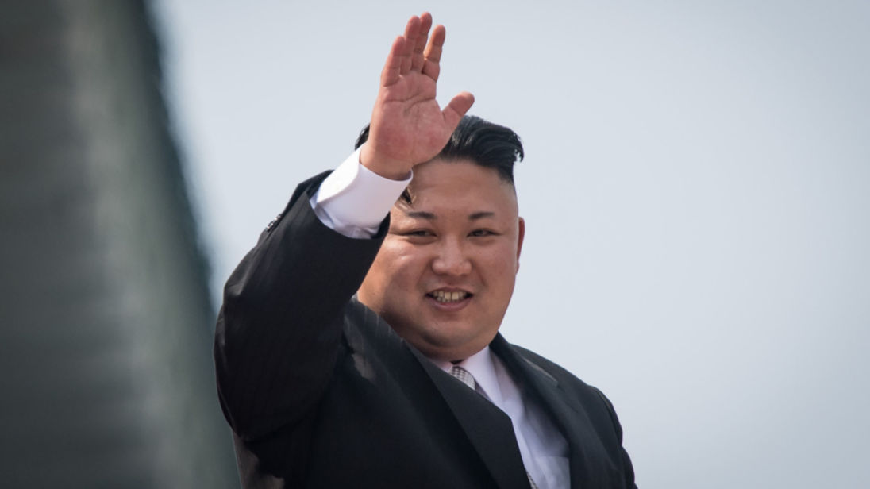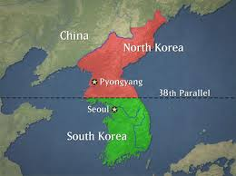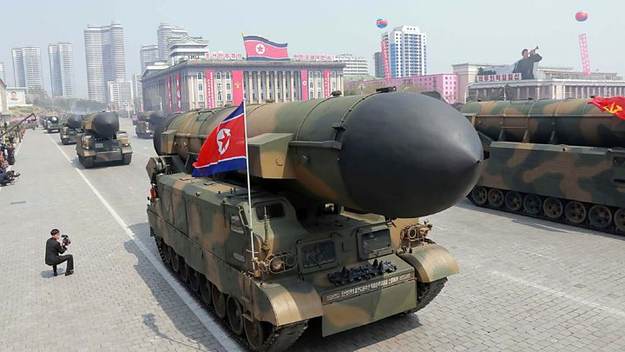

Situation Room Guide on North Korea Side One

Background and Directions:
A country’s foreign policy is a government’s strategy dealing with other nations. Using the checklist below, circle three foreign policy options that you feel the President should take in response to the nuclear threat of North Korea. The goal is to resolve the situation as peacefully as possible.

Option A: Talking tough and putting military pressure on North Korea
It is important that North Korea knows that its actions won’t be tolerated. Given that, the United States should respond North Korea’s missile tests with threats of its own, including military exercises in the region that are designed to intimidate.

The Upside to taking this action:
- Doing so puts pressure on North Korea to think twice about its actions.

The Downsides and Risks of taking this action:
- Talking tough runs the risk of actually increasing the conflict, making it more likely that fighting might break out, with millions possibly killed.
- Talking tough will be used by North Korea as proof that the world is against it, which makes Kim Jong-un more appealing to his people, giving him more power.

Option B: Using more Sanctions Against North Korea
A sanction is a penalty that other countries could impose upon North Korea to limit its participation in the world’s economy. By sanctioning off its energy supply, trade, and money, the world could pressure North Korea to freeze its nuclear weapons programs.

The Upside to taking this action:
- What’s nice about this option is that it doesn’t involve military action, which in turn diminishes the chance of war.

The Downsides and Risks of taking this action:
- Sanctions have been used before on North Korea with limited results.
- Some say that sanctions would hurt the North Korean people but not Mr. Kim.

Situation Room Guide on North Korea Side Two

Option C: Launching a Preemptive attack on North Korea
A “Preemptive Strike” is when one country attacks their enemy first to destroy their ability to make war. Working with its allies and South Korea, the United States could use a preemptive strike to destroy some of North Korea’s weapon systems.

The Upsides to taking this action:
- These strikes could destroy many of North Korea’s weapons.
- Doing so sends a message to North Korea that the world will stand up to it.

The Downside and Risks of taking this action:
- North Korea would probably respond immediately by using thousands of its conventional, chemical, and even nuclear weapons on South Korea’s capital of Seoul, potentially killing hundreds of thousands.
- Many of North Korea’s missiles are on mobile launch carriers, allowing them to be hid from attack, with many of its nuclear weapons buried deep underground.
- In other words, the odds of success for a preemptive attack are low and the risk of North Korean retaliation is high.

Option D: Trying to Intercept and destroy North Korea’s missiles
Using its own missile defense networks in the Pacific, the United States and South Korea could shoot down one of North Korea’s test missiles in mid-flight.

The Upside to taking this action:
- Shooting down one of North Korea’s test missiles would send a message to them that their power is limited, forcing them to live peacefully.
- Doing so would also put more pressure for North Korea to spend money on their military, which in turn might ultimately bankrupt them.

The Downsides and Risks of taking this action:
- While the technology to shoot down a missile is there, experts agree that it would be a “50/50” shot.
- Also, if the shoot-down failed, it might inspire Kim to test more missiles and to be more aggressive, thinking that the U.S. wouldn’t be able to respond.
Situation Room Guide on North Korea Side Three

Option E: Monitoring, Deterring, and Not Overreacting to the Situation
To deter means to prevent something from happening by force. Many believe that North Korea knows that if it uses its nuclear weapons, it will be immediately destroyed by the United States. This concept--known as deterrence--might be a preferable option to war.

The Upside to taking this action:
- Many observers think that Kim Jon-un loves the world’s attention and has no real interest in using his weapons, knowing that if he did, his country would be attacked and that he would likely lose power.

The Downsides and Risks of taking this action:
- If current trends continue, North Korea will have the technology to send a nuclear bomb to any city in the United States, threatening civilization everywhere.

Option F: Pressuring China to cut off North Korea’s energy supply
China is North Korea’s most important ally, biggest trading partner, and main source of food and energy, including 80% of its coal. If China cut off energy supplies to North Korea, it might force Kim to limit his missile tests and to live peacefully. The United States could put heavy fines on Chinese banks to force them to apply this pressure.

The Upside to taking this action:
- These type of actions would put a great deal of pressure on Kim Jon Un, forcing him to limit his military actions and live in peace.

The Downsides and Risks of taking this action:
- Putting pressure on China might be very difficult. They have no interest in North Korea getting weaker, as it might result in millions of refugees crossing into China--as well as the U.S. expanding its power on China’s doorstep.
- Cutting off North Korea’s fuel might just hurt its people--and not those in charge. It might also back Kim into a corner, making him more likely to use its weapons.

Situation Room Guide on North Korea Side Four

Option G: Using all forms of diplomacy and incentives
Diplomacy is the art of dealing with international issues without the use of force. Diplomatic measures involve using money, negotiating political deals, or signing treaties. In other words, the U.S. could use diplomacy by ending the sanctions against North Korea so that it freezes its nuclear tests. Kim might like this, as it would keep him safely in power.

The Upside to taking this action:
- Talking with North Korea would be better than the alternative of fighting, which could kill hundreds of thousands, if not more.
- The world might have to live with a nuclear North Korea to prevent war.

The Downsides and Risks of taking this action:
- North Korea might use the talks as a means of stalling and manipulating others.

Summary and Next Steps:
Based upon what you just read, please circle three of the options below that you feel would be the best response to a nuclear North Korea:

- Talking tough and putting military pressure on North Korea
- Using more Sanctions Against North Korea
- Launching a Preemptive attack on North Korea
- Trying to Intercept and destroy North Korea’s missiles
- Monitoring, Deterring, and not Overreacting to the Situation
- Putting pressure on China to cut off North Korea’s energy supply
- Using all forms of diplomacy and incentives

For Reflection:
What are the upsides to your choice of action--and the potential downsides?

Situation Room Guide on North Korea Side Five

Homework: Processing what you learned from today’s class

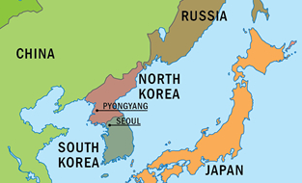

- Name the capital of South Korea: ___________________________________________
- Name the capital of North Korea: ___________________________________________
- Name three other countries in the region: __________________________________________
- Who is the leader of North Korea? ___________________________________________
- If you were the President’s adviser, what actions would you recommend he takes to respond to North Korea? What downsides are connected with the options you’re suggesting?
__________________________________________________________________________
__________________________________________________________________________
__________________________________________________________________________
__________________________________________________________________________
__________________________________________________________________________

